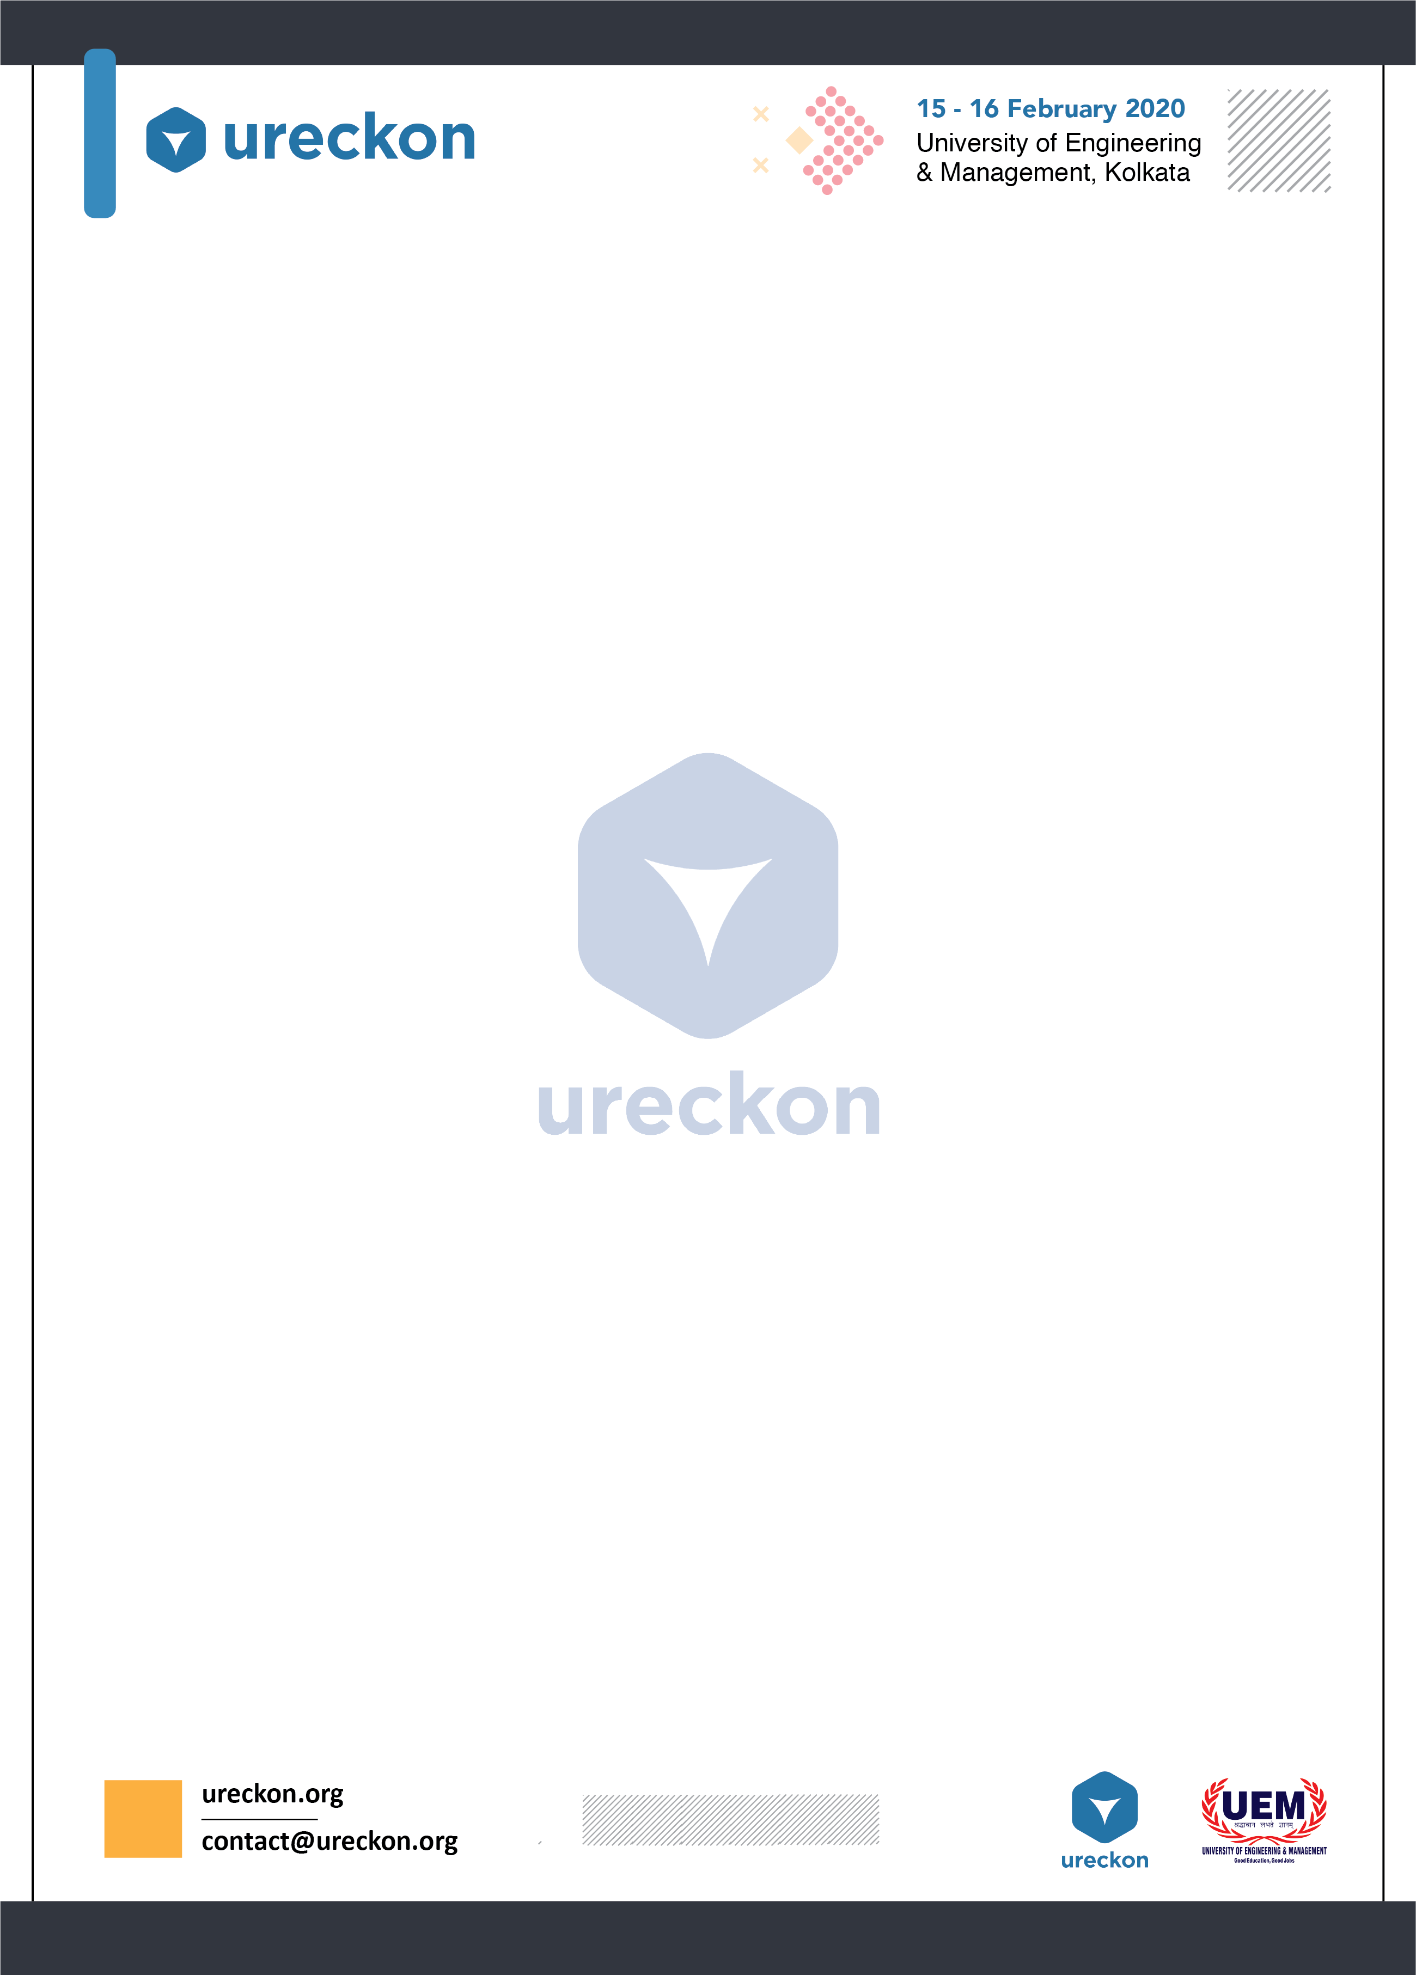

**TECH SCRIPT**

**INTRODUCTION:**

Any sufficiently advanced technology is indistinguishable from magic. After stepping into the third decade of the 21st century, it is appropriate to say that we live in technology. With every passing day, new dimensions are added to this vast domain which intrigues many minds all around the globe. The platform is set, your imagination and creativity are what we seek for.

**PROBLEM STATEMENT:**

**Tech Script** is the technical article writing event of **URECKON**. It is an online event where participants have to write and submit a well-researched article on any topic adhering to technology.

**RULES & REGULATIONS:**

* Submitted articles must be original. Any plagiarism detected will lead to penalization of marks.
* The topic of the article must be strictly adhering to technology.
* Theories (if any) must be stated within quotation marks (“”).
* The participants should submit their articles on the **15th** or the **16th** of **February.**
* Any submissions prior to or post the above- mentioned dates, won’t be considered and will lead to disqualification.
* The participants should mention their details while mailing the article, with the event name as the subject of the mail.
* The article must be mailed at [**ureckon.uemk@gmail.com**](mailto:ureckon.uemk@gmail.com)**.**
* Winners will be notified and will be awarded a significant amount of prize money and certificates.



**JUDGING CRITERIA & MARKING:**

The articles will be judged and marked on the basis of proficiency in writing, choice of topic, clarity and correctness of the research done on the chosen topics. Detailed marking scheme will be uploaded later.

**CO-ORDINATOR:**

**Somlina Ghosh Ray : 8017424905/** [**somlina0320@gmail.com**](mailto:somlina0320@gmail.com)**.**

**Rules are liable to change. Changes will be notified.**

**In case of any queries contact the co-ordinator.**